This Word module should be used for all taxonomic proposals.
Please complete Part 1 and:
either Part 3 for proposals to create new taxa or change existing taxa
or Part 2 for proposals of a general nature.
Submit the completed Word module, together with the accompanying Excel module named in Part 3, to the appropriate ICTV Subcommittee Chair.
For guidance, see the notes written in blue, below, and the help notes in file Taxonomic_Proposals_Help_2018.
Part 1: TITLE, AUTHORS, etc

Code assigned: | 2018.003S.N.v1.Dicipivirus_sp |  | (to be completed by ICTV officers)
Short title: (e.g. “6 new species in the genus Zetavirus”)
1 new species (Cadicivirus B) in the genus Dicipivirus
Author(s):
Roland Zell, Alexander E. Gorbalenya, Tapani Hovi, Andrew M.Q. King, Nick J. Knowles, A. Michael Lindberg, M. Steven Oberste, Ann C. Palmenberg, Gabor Reuter, Peter Simmonds, Tim Skern, Caroline Tapparel, Katja C. Wolthers, Patrick C.Y. Woo
Corresponding author with e-mail address:
Roland Zell (roland.zell@med.uni-jena.de)
List the ICTV study group(s) that have seen this proposal:
A list of study groups and contacts is provided at http://www.ictvonline.org/subcommittees.asp . If in doubt, contact the appropriate subcommittee chair (there are six virus subcommittees: animal DNA and retroviruses, animal ssRNA-, animal ssRNA+, fungal and protist, plant, bacterial and archaeal) |  | Picornaviridae Study Group
ICTV Study Group comments (if any) and response of the proposer:
Date first submitted to ICTV: |  |  | 15/06/2018
Date of this revision (if different to above):

ICTV-EC comments and response of the proposer:

Part 2: NON-STANDARD
Template for any proposal regarding ICTV procedures, rules or policy, not involving the creation of new taxonomy.
Text of proposal:

Part 3: PROPOSED TAXONOMY

Name of accompanying Excel module: 2018.003S.N.v1.Dicipivirus_sp

The taxonomic changes you are proposing should be presented on an accompanying Excel module, 2017_TP_Template_Excel_module. Please enter the file name of the completed module in this box.
Supporting material:
additional material in support of this proposal
Please explain the reasons for the taxonomic changes you are proposing and provide evidence to support them. The following information should be provided, where relevant:
- Species demarcation criteria: Explain how new species differ from others in the genus and demonstrate that these differences meet the criteria previously established for demarcating between species. If no criteria have previously been established, and if there will now be more than one species in the genus, please state the demarcation criteria you are proposing.
- Higher taxa:
  - There is no formal requirement to state demarcation criteria when proposing new genera or other higher taxa. However, a similar concept should apply in pursuit of a rational and consistent virus taxonomy.
  - Please indicate the origin of names assigned to new taxa at genus level and above.
  - For each new genus a type species must be designated to represent it. Please explain your choice.
- Supporting evidence: The use of Figures and Tables is strongly recommended (note that copying from publications will require permission from the copyright holder). For phylogenetic analysis, try to provide a tree where branch length is related to genetic distance.

Create 1 new species (Cadicivirus B) in the genus Dicipivirus

A novel species, named Cadicivirus B from the genus Dicipivirus was identified. Cadicivirus B was found in fecal specimens, blood, ear skin, abdominal muscles and liver tissues of 8 dead and 12 wild-living Northern white-breasted hedgehogs (Erinaceus roumanicus) in Southwest Hungary (Reuter et al., 2017). The authors named the virus hedgehog dicipivirus.

Relation to other picornaviruses:
- Genome layout of hedgehog dicipivirus:
VPg+5'UTR^{IRES}[1A-1B-1C-1D]IGR^{IRES}[2A-2B-2C/3A-3B^{VPg}-3C^{pro}-3D^{pol}]3'UTR-poly(A)
- hedgehog dicipivirus has typical hallmarks of picornaviruses:
- capsid proteins: 1B, 1C, 1D have rhv domains with a drug-binding site,
- 2C^{hel}: GxxGxGKS motif of helicases,
- 3B^{VPg}: Y-3 residue, passeriviruses have two putative 3B^{VPg} peptides,
- 3C^{pro}: GxCGx₁₄GxH motif,
- 3D^{pol}: KDE, PSG, YGDD, FLKR motifs
- Phylogenetic analyses indicate that hedgehog dicipivirus clusters with Cadicivirus A (compare Figs. 1, 2 of supporting material).
Cadicivirus B belongs to genus Dicipivirus because of its dicistronic genome organisation. Phylogenetic analyses based on the amino acid sequence of P1 and 3D regions show that Cadicivirus B is clustered within the same clade as with Cadicivirus A and its strains but is very distinct from other genera of Picornaviridae (Fig. 1 and Fig. 2). Cadicivirus B distinguishes itself from Cadicivirus A in terms of similarities based on P1, P2, P3, 3D, 5’UTR and IGR regions (Table 1). In particular, there is low sequence similarity with the closely related members of Cadicivirus A (amino acid identity of P1 region is 43%; amino acid identity of 3D region is 55%) (Table 1). The divergence of the Cadicivirus B and its closely related viruses at P1 and 3D regions is shown in Table 2.

Table 1: Comparison of nucleotide and amino acid identity between Cadicivirus B and Cadicivirus A.
Virus name | Accession no. |  |  | Cadicivirus B [Hedgehog dicipivirus]
 |  | Amino acid identity (%) |  |  |  |  | Nucleotide identity (%)
 |  | P1 | P2 |  | P3 | 3D | 5'UTR | IGR
Cadicivirus A | JN819202 | 43 | 39 |  | 56 | 55 | 52 | 69
Canine picodicistrovirus strain 236 | JN819203 | 43 | 39 |  | 57 | 55 | 53 | 69
Canine picodicistrovirus strain 244U | JN819204 | 43 | 39 |  | 57 | 55 | 52 | 69

Table 2: Estimates of evolutionary divergence of P1 and 3D regions between sequences.

[ 1] #MF188967 Cadicivirus B [Hedgehog dicipivirus]
[ 2] #JN819204 Canine picodicistrovirus strain 244U
[ 3] #JN819203 Canine picodicistrovirus strain 236
[ 4] #JN819202 Cadicivirus A
[ 5] #KX783423 Rosavirus B1
[ 6] #JF973686 Rosavirus A
[ 7] #KF961188 Megrivirus A
[ 8] #KC876003 Mesivirus 1 strain HK21
[ 9] #EU236594 Bovine rhinitis B virus
[10] #AY593829 Foot-and-mouth disease virus O
[11] #AY421760 Coxsackievirus A2
[12] #FJ445111 Rhinovirus A1

P1 region
[ 1 2 3 4 5 6 7 8 9 10 11 12 ]
[ 1]
[ 2] 0.491
[ 3] 0.491 0.014
[ 4] 0.491 0.000 0.014
[ 5] 0.496 0.558 0.563 0.558
[ 6] 0.529 0.569 0.571 0.569 0.379
[ 7] 0.821 0.810 0.812 0.810 0.826 0.815
[ 8] 0.830 0.826 0.822 0.826 0.812 0.803 0.565
[ 9] 0.844 0.832 0.837 0.832 0.821 0.841 0.857 0.837
[10] 0.828 0.824 0.828 0.824 0.801 0.819 0.859 0.832 0.534
[11] 0.806 0.819 0.819 0.819 0.815 0.817 0.851 0.850 0.764 0.775
[12] 0.808 0.799 0.806 0.799 0.801 0.813 0.833 0.853 0.793 0.775 0.518

3D region
[ 1 2 3 4 5 6 7 8 9 10 11 12 ]
[ 1]
[ 2] 0.429
[ 3] 0.427 0.011
[ 4] 0.431 0.009 0.016
[ 5] 0.463 0.528 0.528 0.528
[ 6] 0.459 0.491 0.491 0.493 0.259
[ 7] 0.651 0.628 0.628 0.631 0.603 0.599
[ 8] 0.635 0.651 0.654 0.654 0.596 0.601 0.358
[ 9] 0.725 0.725 0.722 0.727 0.718 0.702 0.718 0.702
[10] 0.727 0.722 0.722 0.722 0.729 0.722 0.700 0.670 0.353
[11] 0.647 0.693 0.690 0.693 0.663 0.663 0.667 0.670 0.743 0.720
[12] 0.665 0.667 0.672 0.667 0.649 0.665 0.677 0.677 0.734 0.729 0.450

___ within species comparison ___ between species comparison ___ between genera

Exemplar:
Cadicivirus B, cadicivirus B1 (hedgehog cadicivirus) [hedgehog/H14/2015/HUN],
GenBank acc. no. MF188967

Species demarcation criteria:
Based on available sequence data, preliminary species demarcation criteria were defined.
Members of a species of genus Dicipivirus:
- share a common, dicistronic genome organization,
- share greater than 70% aa identity in the P1 (orf 1),
- share greater than 70% aa identity in the non-structural proteins 2C + 3CD.

References:
Reuter, G., Boros, A., Foldvari, G., Szekeres, S., Matics, R., Kapusinszky, B., Delwart, E., Pankovics, P. (2017). Dicipivirus (family Picornaviridae) in wild Northern white-breasted hedgehog (Erinaceus roumanicus). Arch Virol. doi:10.1007/s00705-017-3565-0
Woo, P. C., Lau, S. K., Choi, G. K., Huang, Y., Teng, J. L., Tsoi, H. W., Tse, H., Yeung, M. L., Chan, K. H., Jin, D. Y., Yuen, K. Y. (2012). Natural occurrence and characterization of two internal ribosome entry site elements in a novel virus, canine picodicistrovirus, in the picornavirus-like superfamily. J Virol, 86(5), 2797-2808. doi:10.1128/jvi.05481-11

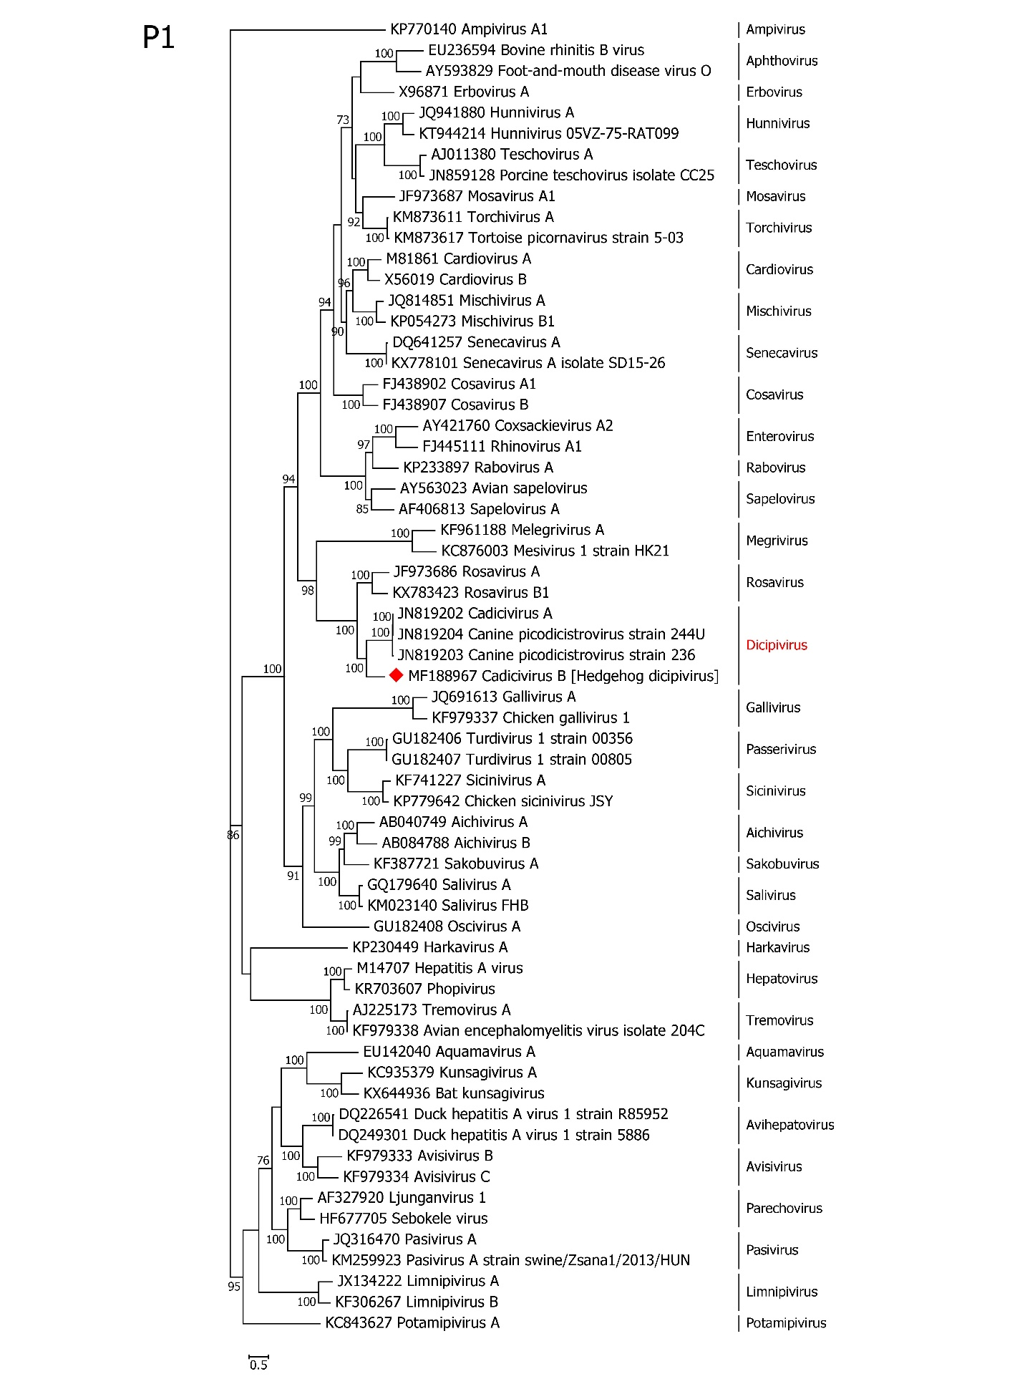
Figure 1: Phylogenetic analysis of amino acid sequence of P1 region among the species from Picornaviridae family using MEGA7. The tree was constructed using the maximum-likelihood method based on LG + G + I + F amino acid distance matrix. The bootstrap values were calculated from 1000 replicates. The proposed name (hedgehog dicipivirus) is indicated by a red diamond (♦).
Sapelovirus
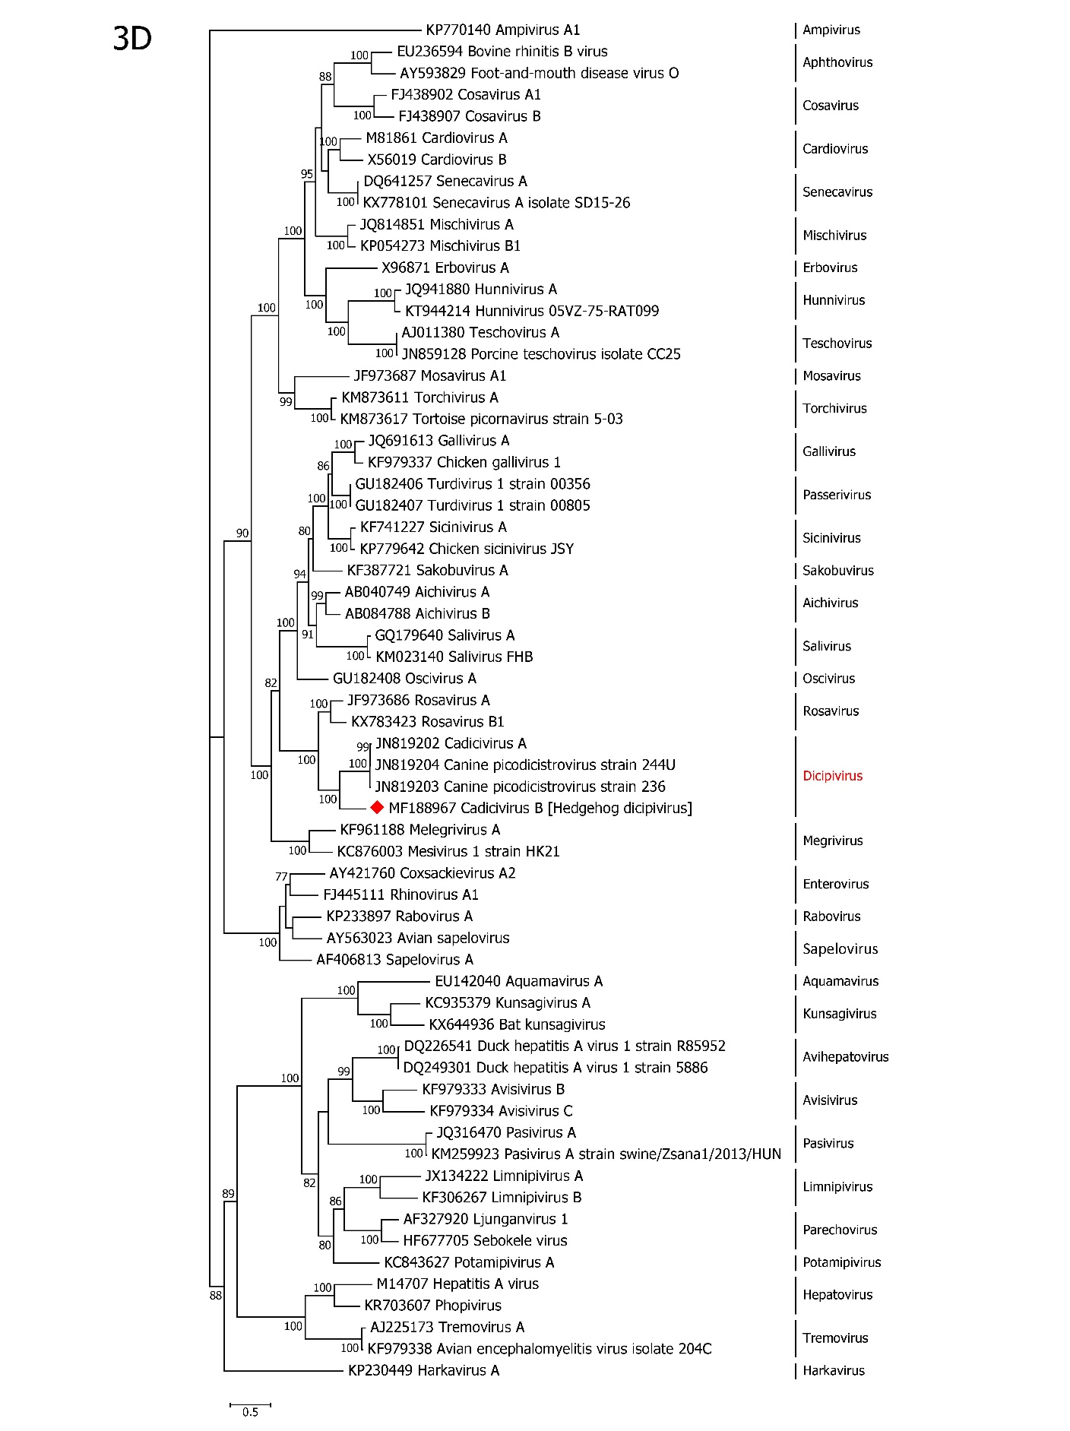
Figure 2: Phylogenetic analysis of amino acid sequence of 3D region among the species from Picornaviridae family using MEGA7. The tree was constructed using the maximum-likelihood method based on LG + G + I amino acid distance matrix. The bootstrap values were calculated from 1000 replicates. The proposed name (Hedgehog dicipivirus) is indicated by a red diamond (♦).

